Table Creation

Table creation script runs without errors.
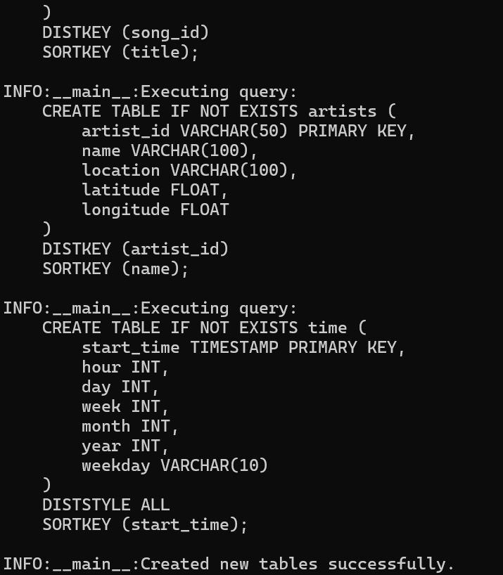

✅ The `create_table.py` script runs successfully.

✅ The script successfully connects to the Sparkify database.

✅ Existing tables are dropped and new tables are created successfully.

💡 When writing Python code, I like to use the pdb module. It allows you to create a breakpoint in your code so that your code stopped at that breakpoint and then you could print out and analyze the variables active at that line. Here is how to use it:

import pdb

...
# Then, when you want to set up a breakpoint, write the following line:
pdb.set_trace()

Staging tables are properly defined.
✅ Staging tables' data types and conditions are all correct. Good job!

Suggestions

💡 By setting the correct data types and constraints, you make your ETL processes more efficient, maintainable, and reliable.

References:

- Data Types and Constraints in SQL Server

Here are some suggestions to improve your CREATE TABLE queries:

1. Explicit Column Definitions: Always specify all columns with their data types and constraints explicitly. This ensures data integrity and clarity.
- Reference: AWS Documentation on CREATE TABLE

2. Appropriate Data Types: Choose the correct data types to match the data accurately. For instance, use `VARCHAR` for strings, `INTEGER` for whole numbers, and `TIMESTAMP` for date-time values.
- Reference: Redshift Data Types

3. NOT NULL Constraints: Use NOT NULL constraints on columns that must always have a value to avoid data inconsistency.
Reference: Redshift: Defining Table Constraints
4. Primary Keys and Unique Constraints: Although Redshift doesn’t enforce primary keys or unique constraints, defining them can help in query optimization and logical data consistency.
Reference: Amazon Redshift best practices for designing tables
5. Compression Encoding: Utilize compression encoding for columns to save space and improve performance. Use COMPUPDATE to let Redshift choose the best encoding.
Reference: Redshift Compression

These practices will ensure your CREATE statements are efficient, clear, and maintain data integrity.

Fact and dimensional tables for a star schema are properly defined.
✅ Data types and conditions of all fact and dimension tables are correct. Good work.

✅ It's nice that you used SORTKEY and DISTKEY to optimize your database performance.
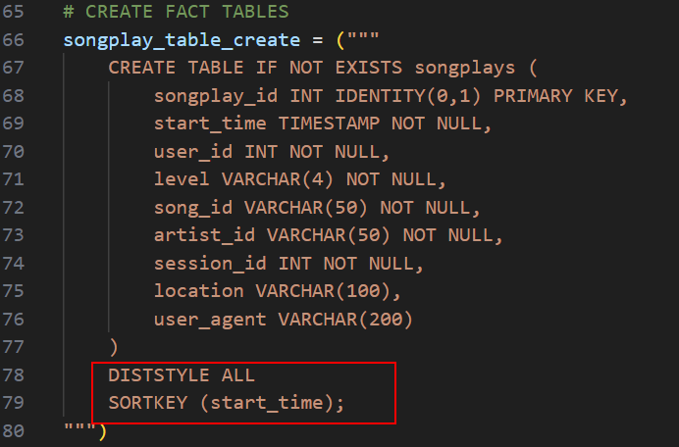

💡 The key to finding the optimal DIST KEY is that this field should be distributed as equally as possible throughout the table. For this reason, a unique primary key is a great candidate to be the DIST KEY, since it has to be unique and thus uniformly distributed in the table. For a deeper discussion on this, read this article.

The choice of sort key depends on the frequency and type of SELECT queries run on your tables. As suggested in Amazon Redshift's documentation, it's best to leave it to Redshift to choose the appropriate sort order—especially when the specific query patterns are not yet known.

ETL

ETL script runs without errors.
✅ The `etl.py` script runs successfully.

✅ The script manages to connect to the Sparkify redshift database.

✅ The data are successfully loaded into the staging tables and then transformed into the five final tables.

💡 Including the REGION parameter in your COPY script is a great practice! As explained in the documentation for COPY from Amazon S3, the REGION setting is required if the Amazon S3 buckets holding the data files are not in the same AWS Region as your Redshift cluster—which is often the case in many ETL projects.

ETL script properly processes transformations in Python.
✅ All INSERT statements are correct.

⚠️ (Optional) The JOIN statements in the songplays INSERT are acceptable, but to be more sure the songplays table does not have incorrect rows, you may also add the duration field in the JOIN statement.
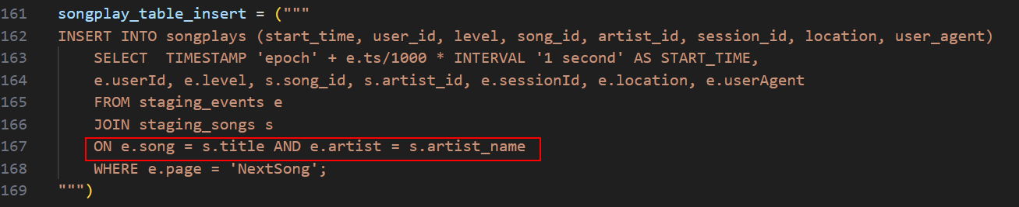

✅ Duplicates are handled properly.

⚠️ I ran the following query in the Query Editor to test for duplicate users:

SELECT user_id, COUNT(*) as count FROM users GROUP BY user_id ORDER BY count DESC;

I then got the following result:

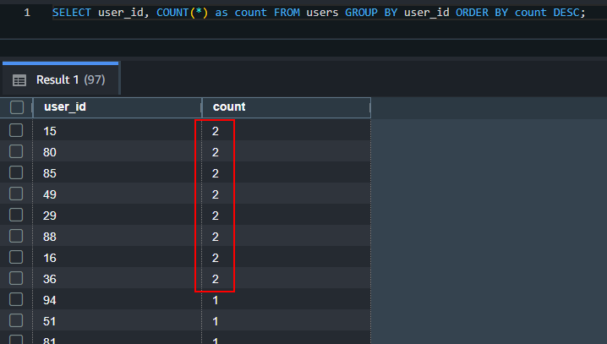

Note: I only entered the staging data from the path `s3://udacity-dend/song-data/A/A/A` to save reviewing time. The exact number of counts will be different if you used the entire dataset.

Notice there that there are rows with duplicated user_id. When duplicates have been handled properly, the `count` field's value should be `1` at all times.

However, you have used GROUP BYs that returned similar results to the SELECT DISTINCT method which is the accepted solution in [the Knowledge Hub](https://knowledge.udacity.com/questions/42129). So you **do not need to change these queries to pass this specification.** Read on if you'd like to learn a better method.

---

Why doesn't GROUP BY work?

INSERT INTO users (user_id, first_name, last_name, gender, level)
SELECT userId, firstName, lastName, gender, level
FROM staging_events
WHERE userId IS NOT NULL
GROUP BY 1, 2, 3, 4, 5;

This query groups by all five columns, meaning if a single user appears multiple times with different `level` values, you'll get multiple rows for the same `user_id`.

How about SELECT DISTINCT? Let's see a generic sample query:

```
INSERT INTO users (user_id, first_name, last_name, gender, level)
SELECT DISTINCT
user_id,
user_first_name,
user_last_name,
user_gender,
user_level
FROM staging_events
WHERE page = 'NextSong'

Consider an event where a user updated his/her subscription. It will be recorded in the `staging_events` as the same user data except for `level`. The SELECT DISTINCT query will still attempt to insert the row in this case because the combination of fields is unique from all pre-existing rows.

The query above would then return an error since it does not follow the PRIMARY KEY constraint for the user ID, since the query will attempt to insert two rows with the same user id but different `level`.

To deal with this problem, we need to INSERT the latest users data from the `staging_events` table. That means, for each unique `userid`, find the row with the highest value of the `ts` field and then enter the relevant information into a new field in the `users` field. This is trickier than it sounds. We cannot use GROUP BY because the fields are not connected to the ID in the rows. For example, in this query:

INSERT INTO users (user_id, name, level)
SELECT userid, name, level FROM (
SELECT MAX(ts), userid, MAX(name) as name, MIN(level) as level
FROM staging_events
GROUP BY userid
ORDER BY userid
) g_staging_events;

`MAX(name) as name, MIN(level) as level` has no connection with the `userid`.

The only workaround then is by using [Common Table Expression (CTE)](https://docs.aws.amazon.com/redshift/latest/dg/r_WITH_clause.html). This feature is supported in Redshift and It allows us to DESC order by the `ts` field, so we always get the latest snapshot of the `users` data **(the following is a pseudocode. Please update it to suit your project. I purposely did not include some fields like firstName, lastName, etc.)**:

INSERT INTO users(user_id, name, level)
WITH uniq_staging_events AS (
SELECT userid, name, level,
ROW_NUMBER() OVER(PARTITION BY userid ORDER BY ts DESC) AS rank
FROM staging_events
WHERE userid IS NOT NULL
)
SELECT userid, name, level
FROM uniq_staging_events
WHERE rank = 1;

Duplicates need to be handled at least for the `users` and `time` tables since they both use the staging_events table that contains duplicates.

Code Quality

The project shows proper use of documentation.
✅ The README document properly describes your project, well done.

✅ Good job including docstrings into your functions.

💡 For the formatting of my docstrings, I prefer to follow Google Style Python Docstrings. When followed properly, this style allows tools such as Sphinx to automatically generate documentation from your code by analyzing only the docstring comments.

The project code is clean and modular.

✅ Your scripts are intuitive and easy to follow. Good job!

💡 Avoiding repetitive code by using functions and loops is important to improve the readability of your code and make it more modular. A modular code means you may reuse some of its components for similar problems.

📚 Python Function Writing Best Practices:
This guide provides a helpful checklist of best practices to follow when writing Python functions. Here’s a summary:
- Make the code explicit.
- One statement per line.
- Use either of these four function arguments: positional, keyword, arbitrary list, and arbitrary dictionary.
- Avoid magical wand (you won’t encounter this often at this stage, so don’t worry).
- Prefix all "internals" (attributes and functions) with an underscore, e.g., def _this_is_a_private_function().
- Raise errors rather than using multiple return statements.
- Use idioms where available (see the article for examples).
- Read PEP 20 (The Zen of Python) and PEP 8 for detailed coding guidelines.
- Check out coding conventions in the article. You’ll encounter them more often as you read Python code—no need to memorize them immediately.

